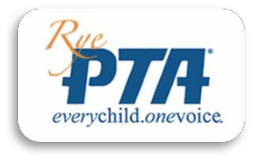

Make a difference by joining the Rye PTA today!
Your child benefits when you join the PTA. Your membership dues and extra contributions help fund PTA programs, school equipment, and events beyond what is offered through the Rye school budget. Examples are:
EVENTS  Family Fun Events, Monster Mash, Spring Soiree, Fun Finale, Bike Rodeo | PROGRAMS  School Assemblies, RJH Play, Speakers, Staff Appreciation, Health Month
AFTER SCHOOL ENRICHMENT  Enrichment activities at RES and RJH including Art, Music, Language, Sports, Science, Cooking…and more | SCHOOL/TEACHER GRANTS  Grants for Playground Equipment, Classroom Enrichment and Materials, Garden Supplies, Bookworm Vending Machine, Surfboards

Dues are only $15/year which provides you with a $5 discount for every after school enrichment class. The PTA aims to raise about $125/student, so please consider making an additional donation to get the school year started off right. We would love for you to join us at our next meeting to see all the awesome things RYE PTA has to offer and to share your ideas for this year!
Yes, I want to support our schools!
Please print and return the bottom section to the school or bring it to a PTA meeting. You may submit your dues by cash, check made payable to Rye PTA, or through Paypal on the Rye PTA website
(https://www.ryepta.org/). THANK YOU!!

Name:

Address:

Email:

Phone:

Student Name(s)/Grade:
□ I grant permission to the Rye PTA to share contact information with other Rye PTA members.

Membership type: | □ Family | □ Staff | □ Community

Membership Dues are a minimum of $15/year.
Additional tax deductible donations are greatly appreciated and go directly to the schools!
Amount paid: $
For PTA Use Only:

Check # Cash
Amount $ Date Rec’d
THANK YOU for joining the RYE PTA! Your membership and support will ensure that this will be a fabulous year!

